|  |  |
| --- | --- |
| Stella Nova Logo | LOGO4 |
| Best Buy Canada Mobile | |
| |  | | --- | | **Signature Capture with Terms Feature Document** |   **Document Version: 1.1**  **Design Date: July 16, 2013** | |
| **Prepared By: Amy Lackas** | |
|  | |

**Table of Contents**

*1.* *Feature Overview* 3

1.1 Feature Description 3

1.2 Assumptions 3

1.3 Parameters and System Settings 3

1.4 Interfaces 3

*2.* *USE CASE: Signature capture with Terms* 4

2.1 Feature Flow 4

2.2 Precondition 4

2.3 Main Flow 4

2.4 Alternate Flows 4

2.5 Post Condition 4

2.6 Special Requirements 5

*3.* *USE CASE: Signature Capture (Terms)* 5

3.1 Feature Flow 5

3.2 Precondition 6

3.3 Main Flow 6

3.4 Alternate Flows 6

3.5 Post Condition 6

3.6 Special Requirements 6

*4.* *Supplemental Specifications* 7

4.1 Electronic Journal 7

4.2 POSLog 7

4.3 Printed Receipts 7

4.4 Tax Exempt Feature 7

4.5 Warranty Feature 7

4.6 Sale Feature 7

4.7 Suspend Feature 7

*4.8* *Total Processing Feature* 7

*5.* *Screen Layouts* 8

5.1 Signature Capture with Terms and Conditions 8

5.2 Signature Capture with Terms and Conditions 10

5.3 Consolidated Signature Capture with Terms and Conditions - Terms 12

5.4 Consolidated Signature Capture with Terms and Conditions – Signature 14

*6.* *Business Sign Off* 15

*7.* *Revision History* 15

*8.* *Appendix A: Glossary* 15

# *Feature Overview*

## Feature Description

The Signature Capture with Terms feature allows the retailer to setup different actions to require a customer signature before the action can be completed. Additionally, Terms and Conditions prompts (e.g. selling a warranty item) can be setup for a signature reason that requires customer acceptance before the action can be completed.

## Assumptions

1. Signatures are only captured electronically.
2. All text displayed by the system is configurable by brand to support multi-language.  Text is defined from an external source or defined within the system.
3. All Manager Overrides are bypassed.

## Parameters and System Settings

|  |  |  |
| --- | --- | --- |
| **Parameter Mnemonic** | **Description** | **Valid Values** |
| Signature Required | Determines if a function or an acceptance of Terms and Conditions requires a signature. The parameter also defines if the signature for a feature can be consolidated. | Current Scope:   * Warranty Item – PSP * Warranty Item – PRP * Item Tax Exempt * Tran Tax Exempt * Warranty Item – Monthly * Subscription Item * General Item Attribute for Signature Capture with Terms * Loyalty Enrollment * Finance Tender * Employee Sale |

## Interfaces

|  |  |
| --- | --- |
| **Interface** | **Description** |
| None |  |

# *USE CASE: Signature capture with Terms*

## Feature Flow



## Precondition

* An action requires a signature.

## Main Flow

1. The system evaluates the consolidation flag on the action requesting a signature.
2. If the consolidation flag is enabled for the action, the system stores the signature request to be prompted during Total Processing use case, the use case ends and the system returns to the calling use case with completed status.
3. The system displays the list of consolidated Terms and Conditions and prompts for acceptance if required.
4. The operator accepts or declines the Terms and Conditions (if applicable).
5. If the Terms and Conditions is declined, the system displays message stating the Terms and Conditions not accepted, the operator acknowledges the message and the use case ends and returns to the calling use case with a not completed status.
6. The system executes the Signature Capture (Terms) Use Case.
7. If the Signature Capture (Terms) use case returns without a signature, the use case ends and the system returns to the calling use case with a not completed status
8. If the Signature Capture (Terms) use case returns with a signature, the use case ends and the system returns to the calling use case with a completed status.

## Alternate Flows

None

## Post Condition

* Signature is captured.
* Terms and conditions are approved.

## Special Requirements

1. If Terms and Conditions are not defined in the database, the system displays only the signature reason.
2. Terms and Conditions and signature prompt occurs after any additional information for the item or transaction has been captured.
3. The signature capture screen contains the reason for the signature. If the signature reason has Terms and Conditions defined, the signature reason is expandable to display the Terms and Conditions and the Yes/No check boxes are enabled.
4. Minimum required length of a signature is not parameterized but a standard 50 pts.
5. If multiple instances of the same signature reason occur in the transaction, the system considers each one as a separate instance. For example, if three PSP-Warranty items are sold, each one is considered a separate signature request and each will require acceptance of Terms and Conditions (if applicable). If signature is consolidated for the reason, each instance will display separate Signature Reason with Terms and Conditions lines.
6. The terms and conditions to display for Finance Tender are the terms defined for the selected Finance Plan.

### Special Offline Requirements

None

### Data Input/Output

|  |  |  |
| --- | --- | --- |
| **Data Element** | **Description** | **Destination** |
| Terms and Conditions | The Terms and Conditions associated with the signature reason. | * E-Journal * Receipt |

# *USE CASE: Signature Capture (Tender)*

## Feature Flow



## Precondition

* Signature required for a tender.

## Main Flow

1. The system prompts the operator to obtain a signature from the customer.
2. The customer signs the device and accepts the entry.
3. If the operator selects to clear the signature, the system refreshes the screen, the signature is removed and the system restarts the Main Flow.
4. If the operator selects to abort, the use case ends and the system returns to the calling use case.
5. If the operator accepts the entry and fails to provide the required signature, the system displays a message, the operator acknowledges the message and the system restarts the Main Flow.
6. The system validates the signature by validating against minimum required length.
7. If the signature does not meet the minimum required length criteria, the system displays message, the operator acknowledges the message, the signature is cleared and the system restarts the Main Flow.
8. If the signature meets the minimum required length criteria, the system logs the signature captured and the reason for the signature.
9. The use case ends and the system returns to the calling use case.

## Alternate Flows

None

## Post Condition

* A signature is captured for a the Signature Capture with Terms reason.

## Special Requirements

1. Minimum required length of a signature is not parameterized but a standard 50 points.

### Special Offline Requirements

TBD

### Data Input/Output

|  |  |  |
| --- | --- | --- |
| **Data Element** | **Description** | **Destination** |
| Signature | The signature captured from the customer. | * POSLog |
| Signature Reason | The reason details for the signature, such as Credit Tender. | * POSLog * E-Journal |

# *Supplemental Specifications*

## Electronic Journal

Electronic journal mockups for this feature are documented in the Electronic Journal document.

## POSLog

POSLog mockups for this feature are documented in the POSLog document.

## Printed Receipts

Printed receipt mockups, where applicable, are documented in the Receipt Generation document.

## Tax Exempt Feature

The Tax Exempt use case is updated to check if the process requires signature to continue with the transaction process. A separate parameter is setup for Item and Transaction Tax Exempt.

## Warranty Feature

The Warranty use case is updated to check if the process requires signature to continue with the warranty process for the PSP and PRP item types.

## Sale Feature

The Total Processing use case is updated to check for consolidated signatures during the total processing

## Suspend Feature

The Suspend Use Case is updated to reflect that any signatures captured prior to suspend or any actions that occur prior to suspend that require a signature will be stored so that upon resuming transaction the signatures logged

## *Total Processing Feature*

The Total Processing use case is updated to check for consolidated signatures during the total processing.

# *Screen Layouts*

## Signature Capture with Terms and Conditions

This screen appears when an action requires a signature. The action may require the signature to be captured at the time the action is completed.

### Mockup

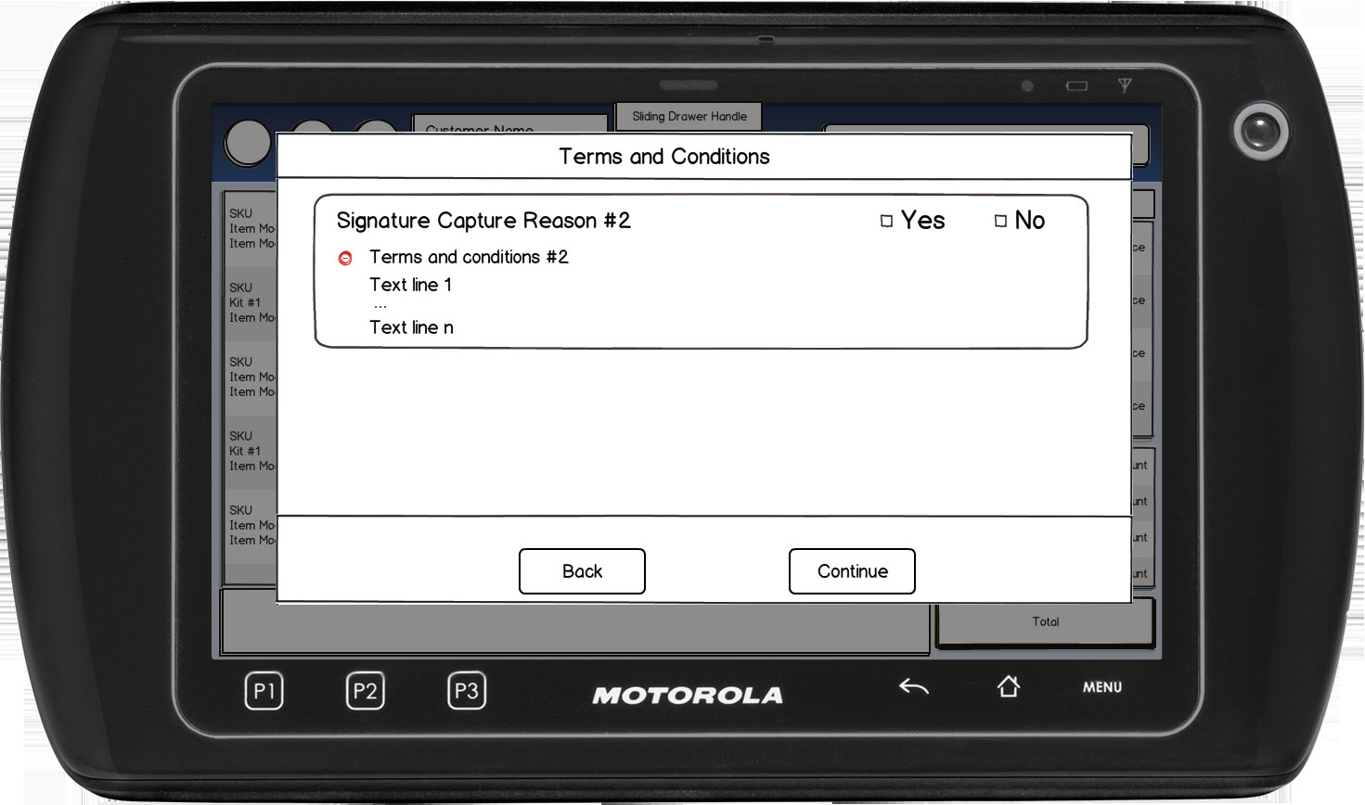

Figure 1: Signature Capture with Terms and Conditions – Terms

### Instruction Text Enhancements

|  |
| --- |
| **Instructions** |
| None |

### Navigation/Menu Key Enhancements

|  |  |  |  |
| --- | --- | --- | --- |
| **Label** | **State** | **Next Screen** | **Notes** |
| Back | Enabled | * Calling use case with action not completed | None |
| Continue | Enabled | * All Terms accepted: Signature Capture with Terms and Conditions – Signature Prompt * At least one Terms not accepted: Terms and Conditions Not Accepted Message | None |
| Expand/Collapse | See Notes | * See Notes | The +/- are displayed only when a signature reason has Terms and Conditions associated with it.  Only one Terms and Conditions can be expanded at a time. As the + next to the Terms and Conditions, the Terms and Conditions for that line are displayed and any other terms are collapsed. |

### Data/Input Field Enhancements

|  |  |  |  |  |  |  |
| --- | --- | --- | --- | --- | --- | --- |
| **Label** | **Editable** | **Req’d?** | **Data Type** | **Min**  **Length** | **Max**  **Length** | **Notes** |
| <Signature Reason> | No | N/A | N/A | N/A | N/A | For each signature reason to be captured, the descriptive text for each signature is displayed on the line (for example ‘Transaction Tax Exempt’). If the signature reason is for an item, the item description is displayed with the Signature Reason (for example ‘Item Tax Exempt: Brand Laptop’).  If the signature has Terms and Conditions, the +/- is present and once expanded the Terms and Conditions are displayed for the particular signature. |
| Yes/No | See Notes | See Notes | Check Box | N/A | N/A | The Yes/No option is only displayed and required when the signature reason has Terms and Conditions defined for it.  Either the Yes or the No needs to be selected for each line. Only one check box per line can be checked at a time. |

### Reason Code Enhancements

|  |  |  |
| --- | --- | --- |
| **Reason Code** | **Valid Values** | **Default Value** |
| None |  |  |

### Terms and Conditions not Accepted

|  |  |
| --- | --- |
| **Description** | The Terms and Conditions not Approved informs the operator that the Terms and Conditions for <signature reason> has not been approved. Upon acknowledging the message, the system returns to the calling use case with action of not completed or to the Sale use case when called from Total Processing |
| **Message** | Terms and Conditions for <Signature Reason> is not approved |
| **Key prompt** | OK |
| **Notes** | Configurable message. |

## Signature Capture with Terms and Conditions

This screen appears when an action requires a signature. The action may require the signature to be captured at the time the action is completed.

### Mockup

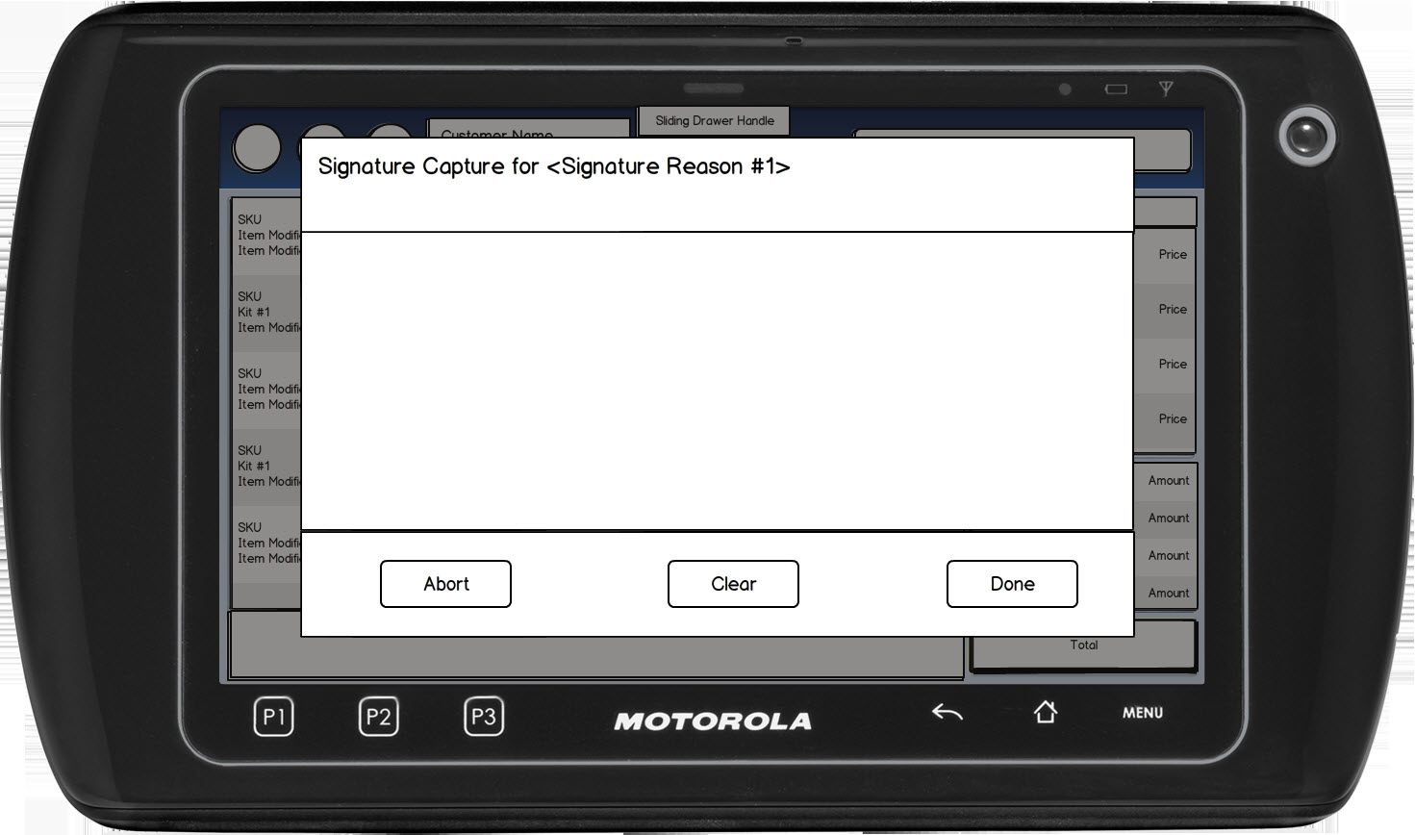

Figure 2: Signature Capture with Terms and Conditions – Siganture

### Instruction Text Enhancements

|  |
| --- |
| **Instructions** |
| None |

### Navigation/Menu Key Enhancements

|  |  |  |  |
| --- | --- | --- | --- |
| **Label** | **State** | **Next Screen** | **Notes** |
| Done | See Note | * Signature capture does not meet minimum length or required data is missing: Invalid Signature * Signature capture meets minimum length: calling use case | Enabled when an entry is made. |
| Clear | See Note | * Signature Capture | Enabled when an entry is made. |
| Abort | See Note | * Sale Use Case | None |

### Data/Input Field Enhancements

|  |  |  |  |  |  |  |
| --- | --- | --- | --- | --- | --- | --- |
| **Label** | **Editable** | **Req’d?** | **Data Type** | **Min**  **Length** | **Max**  **Length** | **Notes** |
| <Signature Reason> | No | N/A | N/A | N/A | N/A | For each signature reason to be captured, the descriptive text for each signature is displayed on the line (for example ‘Transaction Tax Exempt’). If the signature reason is for an item, the item description is displayed with the Signature Reason (for example ‘Item Tax Exempt: Brand Laptop’). |
| Signature Line | Yes | Yes | N/A | See Notes | N/A | Database parameter to define the minimum data points allowed. |

### Reason Code Enhancements

|  |  |  |
| --- | --- | --- |
| **Reason Code** | **Valid Values** | **Default Value** |
| None |  |  |

### Invalid Data Notice

|  |  |
| --- | --- |
| **Description** | The Invalid Data Notice informs the operator that the data entered in the required fields is invalid (e.g. incorrect format, missing). The <ARG> described in the Message is replaced with the name of the data field that contains the invalid data. If there are multiple data fields with invalid data, the system only displays the name of the first data field with invalid data. Upon acknowledging the message, the system returns to the previous screen. |
| **Message** | The following field has invalid data: <ARG>. Please correct the invalid data. |
| **Key prompt** | OK |
| **Notes** | This is a generic message to be reused when required data is incorrect or missing. |

## Consolidated Signature Capture with Terms and Conditions - Terms

This screen appears when an action requires a signature. The action may require the signature to be captured at the time the action is completed.

If a terms and conditions is selected, it is expanded to display the inventory details. If the expanded terms and conditions is selected again, the details are collapsed. If another terms and conditions is selected, the previous item details are collapsed and the selected terms and conditions is expanded.

### Mockup

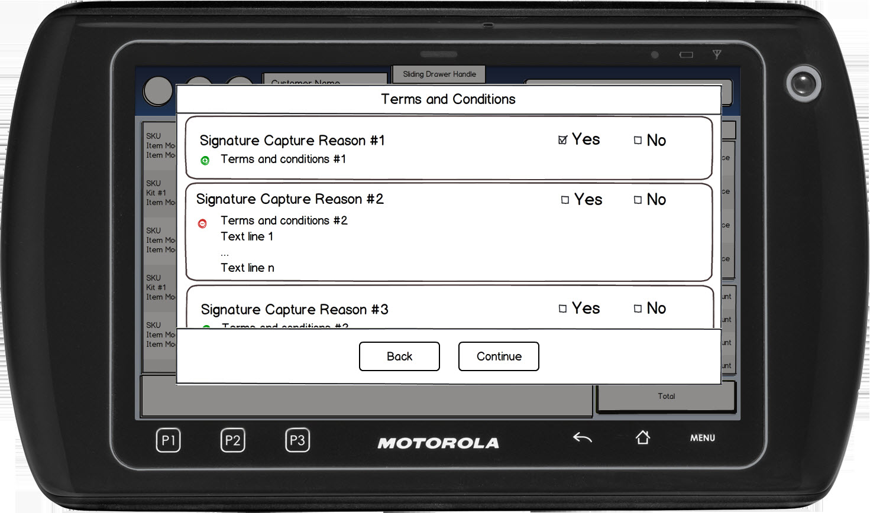

Figure 3: Signature Capture with Terms and Conditions – Terms prompt

### Instruction Text Enhancements

|  |
| --- |
| **Instructions** |
| None |

### Navigation/Menu Key Enhancements

|  |  |  |  |
| --- | --- | --- | --- |
| **Label** | **State** | **Next Screen** | **Notes** |
| Back | Enabled | * Sale use case | None |
| Continue | Enabled | * All Terms accepted: Signature Capture with Terms and Conditions – Signature Prompt * At least one Terms not accepted: Terms and Conditions Not Accepted Message | None |
| Expand/Collapse | See Notes | * See Notes | The +/- are displayed only when a signature reason has Terms and Conditions associated with it.  Only one Terms and Conditions can be expanded at a time. As the + next to the Terms and Conditions, the Terms and Conditions for that line are displayed and any other terms are collapsed. |

### Data/Input Field Enhancements

|  |  |  |  |  |  |  |
| --- | --- | --- | --- | --- | --- | --- |
| **Label** | **Editable** | **Req’d?** | **Data Type** | **Min**  **Length** | **Max**  **Length** | **Notes** |
| <Signature Reason> | No | N/A | N/A | N/A | N/A | For each signature reason to be captured, the descriptive text for each signature is displayed on the line (for example ‘Transaciton Tax Exempt’). If the signature reason is for an item, the item description is displayed with the Signature Reason (for example ‘Item Tax Exempt: Brand Laptop’).  If the signature has Terms and Conditions, the +/- is present and once expanded the Terms and Conditions are displayed for the particular signature. |
| Yes/No | See Notes | See Notes | Check Box | N/A | N/A | The Yes/No option is only displayed and required when the signature reason has Terms and Conditions defined for it.  Either the Yes or the No needs to be selected for each line. Only one check box per line can be checked at a time. |

### Reason Code Enhancements

|  |  |  |
| --- | --- | --- |
| **Reason Code** | **Valid Values** | **Default Value** |
| None |  |  |

### Terms and Conditions not Accepted

|  |  |
| --- | --- |
| **Description** | The Terms and Conditions not Approved informs the operator that the Terms and Conditions for <signature reason> has not been approved. Upon acknowledging the message, the system returns to the calling use case or to the Sale use case when called from Total Processing |
| **Message** | Terms and Conditions for <Signature Reason> is not approved |
| **Key prompt** | OK |
| **Notes** | Configurable message. |

## Consolidated Signature Capture with Terms and Conditions – Signature

This screen appears when an action requires a signature. The action may require the signature to be captured at the time the action is completed.

### Mockup

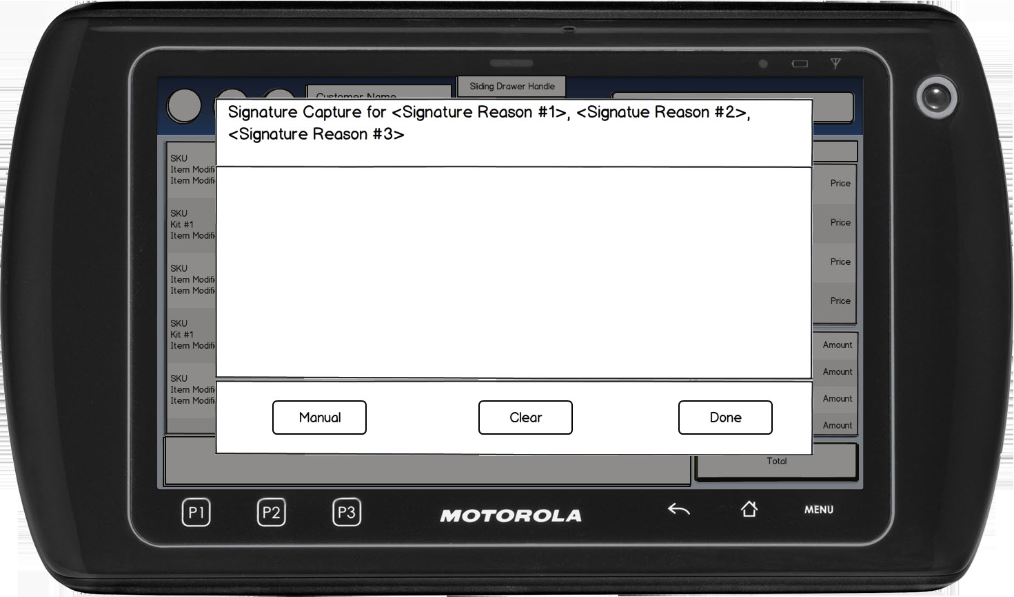

Figure 4: Signature Capture with Terms and Conditions – Signature prompt

### Instruction Text Enhancements

|  |
| --- |
| **Instructions** |
| None |

### Navigation/Menu Key Enhancements

|  |  |  |  |
| --- | --- | --- | --- |
| **Label** | **State** | **Next Screen** | **Notes** |
| Done | See Note | * Signature capture does not meet minimum length or required data is missing: Invalid Signature * Signature capture meets minimum length: calling use case | Enabled when an entry is made. |
| Clear | See Note | * Signature Capture | Enabled when an entry is made. |
| Manual | See Note | * Capture Signature Manually | Displayed only if the Manual Signature Allowed for Tender parameter is enabled. |

### Data/Input Field Enhancements

|  |  |  |  |  |  |  |
| --- | --- | --- | --- | --- | --- | --- |
| **Label** | **Editable** | **Req’d?** | **Data Type** | **Min**  **Length** | **Max**  **Length** | **Notes** |
| <Signature Reason> | No | N/A | N/A | N/A | N/A | For each signature reason to be captured, the descriptive text for each signature is displayed on the line (for example ‘Transaciton Tax Exempt’). If the signature reason is for an item, the item description is displayed with the Signature Reason (for example ‘Item Tax Exempt: Brand Laptop’). |
| Signature Line | Yes | Yes | N/A | See Notes | N/A | Database parameter to define the minimum data points allowed. |

### Reason Code Enhancements

|  |  |  |
| --- | --- | --- |
| **Reason Code** | **Valid Values** | **Default Value** |
| None |  |  |

### Invalid Data Notice

|  |  |
| --- | --- |
| **Description** | The Invalid Data Notice informs the operator that the data entered in the required fields is invalid (e.g. incorrect format, missing). The <ARG> described in the Message is replaced with the name of the data field that contains the invalid data. If there are multiple data fields with invalid data, the system only displays the name of the first data field with invalid data. Upon acknowledging the message, the system returns to the previous screen. |
| **Message** | The following field has invalid data: <ARG>. Please correct the invalid data. |
| **Key prompt** | OK |
| **Notes** | This is a generic message to be reused when required data is incorrect or missing. |

# *Business Sign Off*

|  |  |  |
| --- | --- | --- |
| **Name** | **Organization** | **Date** |
| <Name of signer> | <Organization of signer if applicable> | <date of sign off> |

# *Revision History*

|  |  |  |  |
| --- | --- | --- | --- |
| **Reviser** | **Revision** | **Date** | **Version** |
| Amy Lackas | Initial document created. This version includes the following changes: Added Employee Transaction, Finance Plan. | 07/16/2013 | 1.0 |
| Amy Byers | Corrected Heading for Section 3 to indicate capturing signature for Tender not Terms. | 10/6/2014 | 1.1 |

# *Appendix : Glossary*

|  |  |
| --- | --- |
| **Term** | **Definition** |
|  |  |